Synopsis

Project Title-
Employee Salary Prediction Using Regression Based Machine Learning

Problem Id: 03

Student Name-Ansh Gupta (Leader), Agamya Saini, Amritaanshu Dheeman
University Roll number-2028391, 2028385, 2028390
Section-L

- Problem Description:

In today’s organizations, deciding an employee’s salary is not a simple task, as it depends on many important factors such as experience, education level, job role, performance, skills, and even organizational conditions.
In most cases, salary decisions are made manually by managers or HR departments, which can sometimes lead to inconsistency, bias, or lack of transparency. This makes it difficult to ensure fair and accurate salary distribution among employees. Therefore, there is a need for a system that can predict salaries in a more reliable, consistent, and data-driven manner.
In this project, we aim to build a machine learning model that can predict employee salary based on multiple input features. Since real company data is not easily accessible due to privacy and confidentiality issues, we have created a synthetic dataset consisting of 20 features that simulate a realistic working environment.
These features include both numerical and categorical variables that influence salary in real-world scenarios.
The project also involves performing exploratory data analysis to understand patterns and relationships within the data.
Data preprocessing techniques such as cleaning, encoding, and normalization are applied to prepare the dataset for model training. Feature selection is used to identify the most important factors affecting salary prediction. Multiple regression models are implemented and compared to determine the best-performing model.
Overall, this project helps in understanding how different factors influence employee salary and provides a more efficient and unbiased approach for decision-making in organizations.

- Steps of Implementation:
The project follows a structured machine learning pipeline consisting of the following phases:

1.Data Collection / Generation-
Instead of relying on the synthetic data, the dataset is collected from the Kaggle platform ( already mentions Kaggle as a source). Kaggle provides real-world datasets related to employee salary and job attributes.
The dataset used in this project contains 20 features such as Experience (years) ,Education Level,Job Role ,Department ,Skills ,Performance Rating ,Company Size,Location ,Salary (target variable) etc.The dataset is downloaded in CSV format from Kaggle and loaded into Python using Pandas.
In case of missing attributes or to simulate additional conditions, synthetic data generation is also performed to enhance the dataset by manually in the excel and then csv is imported .

2. Exploratory Data Analysis (EDA)
After loading data in step-1,now we understanding, cleaning, and analysis of the dataset to extract meaningful insights and prepare it for building the Employee Salary Prediction model.
• Data Understanding-
- The dataset was explored using:
  - head() → to view sample employee records
  - info() → to check data types and missing values
  - describe() → to analyze salary statistics (average salary, min, max, etc.)
- This helped us to understand how different features like experience and education are distributed and how they relate to salary.
• Data Cleaning-
- The dataset was cleaned to ensure accuracy:
  - Missing values were identified using isnull() and handled using dropna() or fillna() .
  - Duplicate employee records were removed using drop_duplicates() .
  - Inconsistent entries in features like job role and education were corrected .
- This step ensured that salary prediction is not affected by incomplete or incorrect employee data.
• Outlier Detection and Handling-
- Outliers (extremely high or low salary values) were detected using statistical methods like IQR:
  - Q1 = data.quantile(0.25)
  - Q3 = data.quantile(0.75)
  - IQR = Q3 - Q1
- Values outside (Q1 - 1.5*IQR) and (Q3 + 1.5*IQR) were treated as outliers.
- Unrealistic salary values or abnormal experience entries were removed or adjusted to prevent the model from learning incorrect patterns.
• Data Analysis & Visualization-
- Visualization techniques were used to understand relationships:
  - Histogram (data['Salary'].hist()) → to observe salary distribution
  - Scatter plot (plt.scatter()) → to analyze how experience affects salary
  - Heatmap (sns.heatmap(data.corr())) → to identify important features influencing salary
- We observed that experience and performance had a strong impact on salary, which helped in feature selection.
• Outcome of EDA-
- Identified key factors affecting employee salary (e.g., experience, education)
- Removed missing values, duplicates, and outliers from employee dataset .
- Understood relationships between features and salary .
- Prepared a clean and structured dataset for building the salary prediction model

3. Data Preprocessing-
In this step, the cleaned dataset was transformed into a format suitable for machine learning models. This includes converting categorical data into numerical form, scaling numerical features, and preparing data for training.
• Handling Categorical Data-
- Machine learning models require numerical input, so categorical features were converted into numeric values.
- This was done using encoding methods such as:
  - data['JobRole'].astype('category').cat.codes
- Other categorical columns like education and department were also encoded in a similar way.
• Feature Scaling-
- Numerical features were scaled to bring all values into a similar range.
- This was done using StandardScaler() from sklearn.
- Scaling prevents features with large values from dominating the model.
• Splitting Dataset-
- The dataset was divided into training and testing sets using train_test_split().
- This helps in evaluating model performance on unseen data.
• Verifying Preprocessed Data-
- After preprocessing, the dataset was checked using data.head() and data.shape.
- This ensures that all transformations were applied correctly and the dataset is ready for model training.
• Outcome of Data Preprocessing-
- All categorical features converted into numerical form
- Numerical features scaled properly
- Dataset divided into training and testing sets
- Data prepared for regression model implementation.

4. Feature Selection-
In this step, only the most relevant features were selected from the dataset to improve model performance and reduce unnecessary complexity.
• Removing Redundant Features-
- Features that provide similar information or are not useful for prediction were removed.
- This helps in reducing duplication and simplifying the dataset.
• Applying Forward Selection-
- Forward selection is a step-by-step method where features are added one at a time based on their importance.
- The process starts with no features, and then features are added if they improve the model performance.
- Steps followed:
  - Start with an empty feature set
  - Train the model using one feature at a time
  - Select the feature that gives the best performance (based on score)
  - Add the selected feature to the model
  - Repeat the process by adding remaining features one by one
  - Stop when no further improvement is observed
- This can be implemented using sklearn:
  - from sklearn.feature_selection import SequentialFeatureSelector
  - Apply it with a regression model like LinearRegression()
• Selecting Final Feature Set-
- After applying forward selection, only the most important features were retained.
- The final selected features were verified using data.columns.
• Outcome of Feature Selection-
- Reduced number of input features
- Selected only important variables affecting salary
- Improved model efficiency and accuracy
- Prepared optimized dataset for model trainining.

5. Model Development-
In this step, regression models were implemented to learn the relationship between selected features and the target variable (salary).
• Applying Linear Regression-
- Linear Regression was used as the base model to understand the relationship between input features and salary.
- It was implemented using LinearRegression() from sklearn.
- Steps followed:
  - Import the model using from sklearn.linear_model import LinearRegression
  - Create model object → model = LinearRegression()
  - Train model using model.fit(X_train, y_train)
• Applying Ridge Regression-
- Ridge Regression was applied to reduce overfitting using regularization.
- It controls large coefficient values and improves model generalization.
- Steps followed:
  - Import using from sklearn.linear_model import Ridge
  - Create model → ridge = Ridge()
  - Train using ridge.fit(X_train, y_train)
• Applying Lasso Regression-
- Lasso Regression was used to perform regularization and automatic feature selection.
- It can shrink some coefficients to zero, removing less important features.
- Steps followed:
  - Import using from sklearn.linear_model import Lasso
  - Create model → lasso = Lasso()
  - Train using lasso.fit(X_train, y_train)
• Generating Predictions-
- After training, predictions were generated using:
  - model.predict(X_test)
  - ridge.predict(X_test)
  - lasso.predict(X_test)
The performance of all models was compared using metrics like r2_score(), mean_squared_error(), and mean_absolute_error().
The model with the highest R² score and lowest error values was selected as the best model for salary prediction.
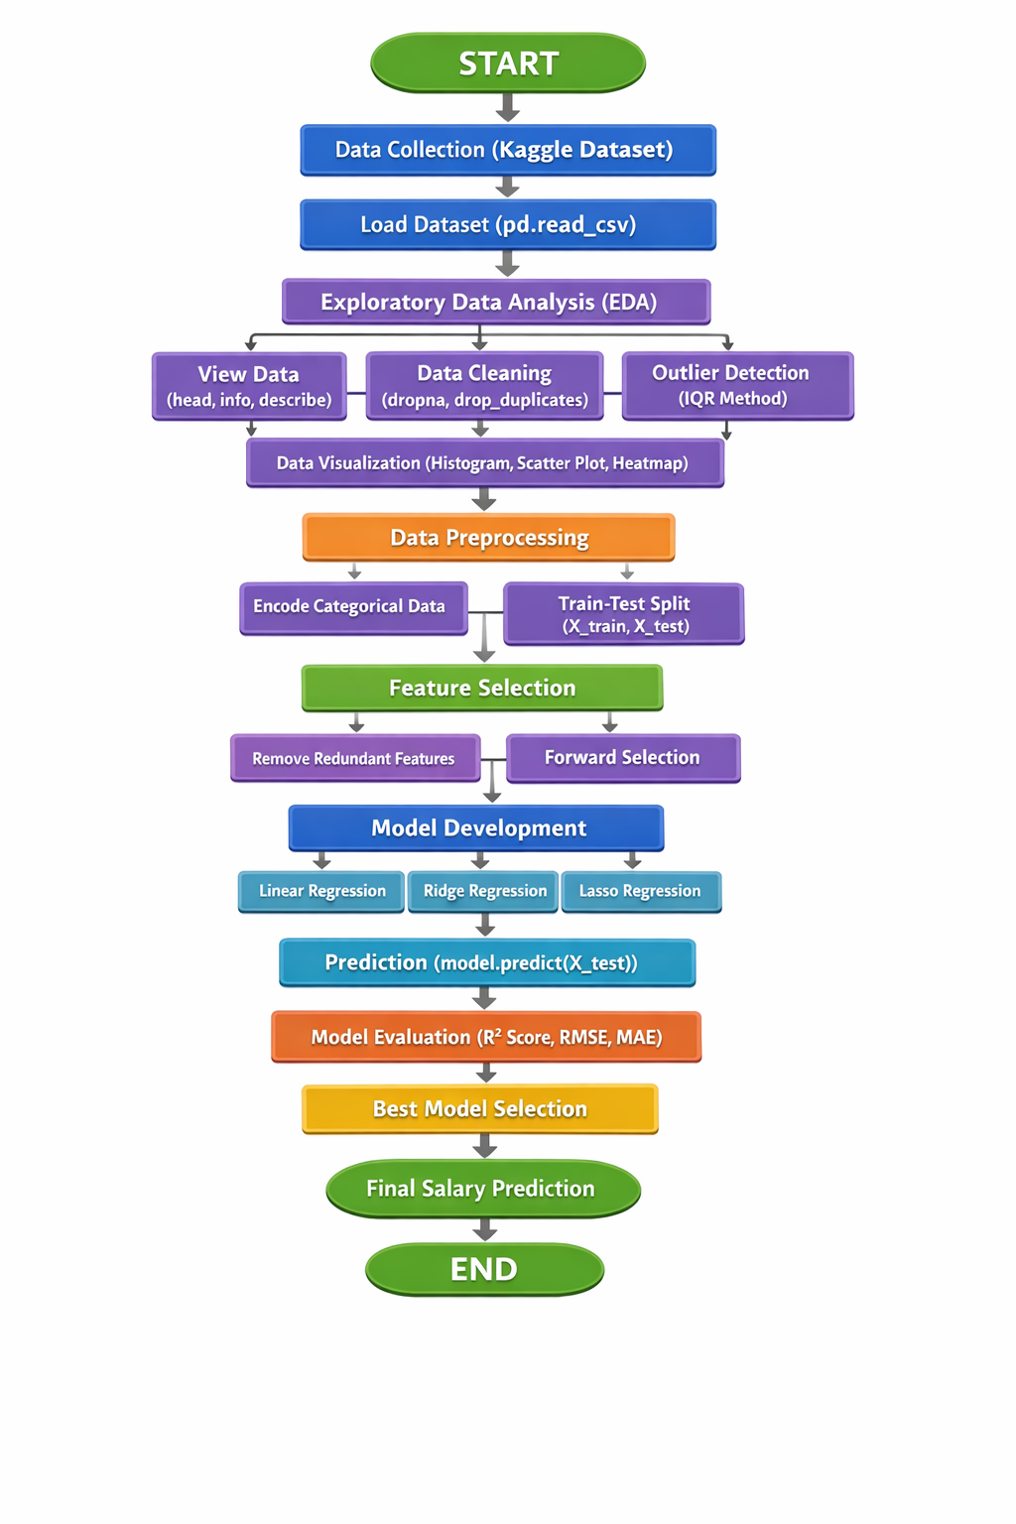
Fig. 1 Architecture Diagram

- Expected Modules/ Libraries to be used :

- NumPy-
NumPy is a fundamental library used for numerical computations in Python. It provides efficient array structures and mathematical functions required for data generation and manipulation. It is widely used for handling large datasets and performing complex calculations.

- Pandas-
Pandas is used for data manipulation and analysis through its DataFrame structure. It helps in organizing, filtering, and processing structured data efficiently. It also provides functions for reading and writing datasets in formats like CSV.

- Matplotlib-
Matplotlib is a visualization library used for creating basic plots such as histograms, line graphs, and scatter plots. It helps in understanding data trends and patterns visually. It is essential for representing analysis results graphically.

- Seaborn-
Seaborn is built on top of Matplotlib and is used for advanced statistical visualizations. It provides better-designed plots such as heatmaps and pair plots. It helps in identifying relationships and correlations between variables.

- Scikit-learn-
Scikit-learn is a machine learning library used for implementing algorithms and models. It provides tools for preprocessing, feature selection, model training, and evaluation. It simplifies the development of machine learning pipelines.

- Expected Evaluation metrics and Plots to be used:
To evaluate the performance of the regression models, multiple metrics and visualization techniques are used to ensure accurate and reliable results.

- R² Score-
R² score measures how well the regression model explains the variability of the dependent variable (salary). It indicates the proportion of variance captured by the model. A higher value represents better model performance.

- RMSE (Root Mean Squared Error)-
RMSE measures the average magnitude of prediction errors by taking the square root of squared differences. It gives more importance to larger errors, making it useful for detecting significant deviations. Lower RMSE indicates better accuracy.

- MAE (Mean Absolute Error)-
MAE calculates the average absolute difference between predicted and actual values. It provides a simple and interpretable measure of error. It is less sensitive to outliers compared to RMSE.

Visualization Plots-

- Histogram-
- A histogram shows how data values are distributed. It divides data into bins and shows frequency of values.
- In this project, data['Salary'].hist() was used. Helped to understand how salary values are spread .Identified whether salary is normally distributed or skewed .Detected possible outliers (very high/low salaries)

- Scatter Plot-
- A scatter plot shows the relationship between two variables. Each point represents one data record.
- Created using plt.scatter(x, y) .Used to analyze relationship between experience and salary .Helped to see trend (salary increases with experience) .Useful for identifying linear or non-linear patterns

- Heatmap-
- A heatmap shows correlation between multiple features. Values range from -1 to +1 (negative to positive correlation).
- Created using sns.heatmap(data.corr()) .Identified which features strongly affect salary .Helped in feature selection .Made it easy to compare multiple variables at once

- Required topics from the subject:

1. Data Preprocessing-
Data preprocessing is used to prepare the dataset for machine learning. It involves organizing, formatting, and transforming raw data into a structured form. This step ensures that the dataset is clean and suitable for further analysis.

2. Data Cleaning-
Data cleaning is performed to handle missing or inconsistent values in the dataset. Techniques such as filling missing values using mean/mode and removing unwanted data are applied. This improves data quality and model performance.

3. Outlier Detection (IQR Method)-
Outliers are extreme values that can negatively affect model accuracy. The Interquartile Range (IQR) method is used to detect and remove such values. This helps in making the model more robust and reliable.

4. Feature Scaling (StandardScaler)-
Feature scaling is used to normalize numerical data so that all features have similar ranges. This prevents bias in model learning due to large value differences. It improves convergence and accuracy of regression models.

5. Train-Test Split-
The dataset is divided into training and testing sets to evaluate model performance. The training set is used to train the model, while the testing set is used to check its accuracy. This ensures proper validation of the model.

6. Linear Regression-
Linear Regression is used to establish a relationship between input features and salary. It predicts salary as a continuous value based on independent variables. It is one of the simplest and widely used regression techniques.

8. Prediction-
Prediction is the process of using the trained model to estimate salary for new input data. The model takes employee features as input and generates a salary output. This demonstrates the practical use of the machine learning model.

- Platform Required:

- Jupyter Notebook-
Jupyter Notebook is used for writing, executing, and testing code in an interactive environment. It allows combining code, outputs, and visualizations in one place. This makes it ideal for data analysis and experimentation.

- Python (IDLE / VS Code)-
Python is the main programming language used for implementing the project. IDEs like IDLE and VS Code provide an environment for writing, debugging, and running code efficiently. They support various libraries required for machine learning.

- GitHub-
GitHub is used for version control and managing the project repository. It allows multiple team members to collaborate and track changes in the code. It also helps in organizing the project into phases and sharing it with others.

- Books and Link Sources:

- Python for Data Analysis – Wes McKinney

- Hands-On Machine Learning with Scikit-Learn, Keras, and TensorFlow – Aurélien Géron

- https://scikit-learn.org⁠ - for official documentation of machine learning models and preprocessing.

- https://www.kaggle.com⁠ - for dataset and practice.

- https://pandas.pydata.org⁠ - for official documentation of data analysis and manipulation.

